Money Cost Automation Serivce
Use Case Document

About This Document
Prepared by | Manpreet Singh
Version: | 1
Date: | 03/30/2005
Project Manager: | Nidhi Quarve
Sponsor: | Nhep Hank


Document History
Reviewed By
Role | Person
References
[INSTRUCTIONS - Enter document title and its file name for each referenced document]
Document Title | File Name/Link

Revision Record
Version | Date and Sections | Changed By | Change
V1 | 03/30/2005 | Manpreet Singh | Created
To view this document without instructions (i.e. just examples) use Tools/Options/View and check off Hidden text
- Blue Text in italics is used to describe the sections and instructions and who usually responsible for filling it in
- This document may contain several use cases and UIs to describe a complete functional component of an application.
- Included / exclude Use case(s) and UI section(s) as appropriate for the functional areas being documented.
- If there is no UI for the use case(s) being described then delete the UI section, similarly if this is just a UI doc, then delete the use case section. This also applies to the notifications section.

Contents
Analyst and whomever will update this document.
To add a table of contents use: Insert/Index & Tables/Table of Contents - Show level 2.
Remember to update this after editnfg the document to refresh the page numbers.
A. Use Case Overview Diagram 5
B. Use Case(s) 6
B.1 Process Multiple Money Cost Files 6
B.1.a Actor(s) and access channels 6
B.1.b Goal 6
B.1.c Pre-Condition(s), Trigger event(s), Security and assumption(s) 6
B.1.d Post Conditions 6
B.1.e Business Rules 6
B.1.f Issues 6
B.2 Yearly Backup Of Existing Files 7
B.2.a Actor(s) and access channels 7
B.2.b Goal 7
B.2.c Pre-Condition(s), Trigger event(s), Security and assumption(s) 7
B.2.d Post Conditions 7
B.2.e Business Rules 7
B.2.f Issues 8
B.3 Process Money Cost File 8
B.3.a Actor(s) and access channels 8
B.3.b Goal 8
B.3.c Pre-Condition(s), Trigger event(s), Security and assumption(s) 8
B.3.d Post Conditions 8
B.3.e Business Rules 8
B.3.f Issue s 10

Use Case Overview Diagram
Analyst: Include a diagram to show how the use case(s) contained in this document interact, including interaction with other use cases(s) outside this document
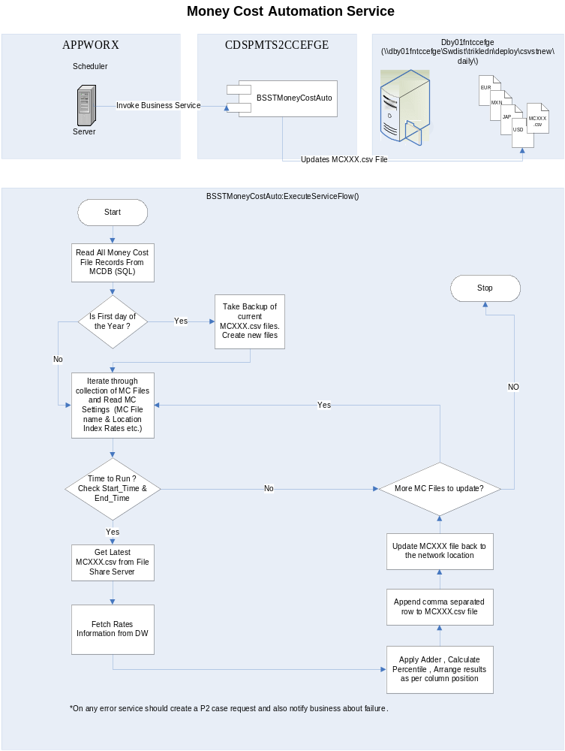

Use Case(s)

Process Multiple Money Cost Files

Actor(s) and access channels
Analyst: Describe each actor and how they are expected to access this function
Input: Invoke Money Cost Automation Service.
Output: Multiple MCXXX.csv files generated as defined in the Money Cost Configuration Database.

Goal

Generate Money Cost Files for multiple currencies defined in the Money Cost Configuration Database.

Pre-Condition(s), Trigger event(s), Security and assumption(s)
Analyst: Describe the state of affairs prior to this use case being invoked, as well as what caused this use case to be invoked and any security restrictions that apply.

Trigger executed by App Worx agent to invoke the Money Cost Automation service.

Post Conditions

Success
Analyst: Describe what should happen when this use case completes successfully
Updation of all Money Cost Files Defined in the Money Cost Configuration Database.

Failure
Failure to update any one or all the money Cost Files defined in the Money Cost Configuration Database.
Analyst: Include a flow of this use case as well as any other use cases it interacts with

Business Rules
Analyst: Describe the business rules for each processing step illustrated in the flow diagram

Issues
Flow Step | Rule / Message | Design notes
Read MC_Files table to get a list of Money Cost Files to be processed | Failure to read any or all the records from the configuration table should generate a Clarify queue for this application identified at the Global level in the registry. | Read all the records from MC_Files table of MoneyCost database and create a recordset object to iterate through.
Process Individual records in the recordset. | Failure to update any one / all the money cost files should result in a case creation in the clarify queue respective to the Money Cost file identified by MC_FILE.ClarifyQueue attribute.
Analyst and whomever will update this document.
Describe any issues that are encountered and their resolutions. This can include business as well as technical issues.
Issue | Resolution | Designer’s notes

Process Money Cost File

Actor(s) and access channels
Analyst: Describe each actor and how they are expected to access this function
Input: Money Cost File being processed.
Output: Updated MCXXX.csv file.

Goal

The existing Money Cost File needs to be updated with latest interest rates information available from the Money Cost data warehouse.

Pre-Condition(s), Trigger event(s), Security and assumption(s)
Analyst: Describe the state of affairs prior to this use case being invoked, as well as what caused this use case to be invoked and any security restrictions that apply.

Current Money Cost File being Processed.

Post Conditions

Success
Analyst: Describe what should happen when this use case completes successfully
Updated Money Cost file with rates from the Data warehouse for a particular date.

Failure
Failure to update the Money Cost File with latest rates as of a particular date from the data warehouse.
Analyst: Include a flow of this use case as well as any other use cases it interacts with

Business Rules
Analyst: Describe the business rules for each processing step illustrated in the flow diagram
Flow Step | Rule / Message | Design notes
Check if Time to Run | Only check if for the Money Cost File a Time Window is specified (Start Time & End Time both are not NULL). If both are defined, Check if current execution time falls between the Start Time & End Time defined for the MC File.  If Yes, Process the File Else Skip to the next MC Record. | Check MC_File.StartTime & MC_File.EndTime values.
Get Latest MC File. | If failed to fetch the latest file from the server. Raise a ticket in the Clarify Queue specific to the file and add details on the error on why the latest file was not pulled from the server. | Fetch the latest MC file from the FTP Location specified in the registry and copy over to a local working directory defined in the Registry settings for the Money Cost Service.  Also create a backup copy of the file at the backup Path location defined in the registry. Name of the Backup file should be BKMMDDYYYY.MCXXX.csv.  Where BKMMDDYYYY is the process date.  MCXXX is the MC_Code for the file being processed.
Load MC File into ADO Recordset
Calculate Process Date |  | The Process date for any MC file should be the Service Execution Date – Days_To_Skip defined for the Money Cost File.
Is Process Date = 01-Jan | . | Check if the date for which the file is being processed 01-Jan. If yes, Save the whole ADO table records as prior year file on the network path specified in the MC_FILE record. Example MCUSD2004.csv.  Once the file is saved successfully, Delete all the records from the ADO record set and continue adding new record for the process date

Delete Exisitng Data for Process Date. |  | Query the MC File Recordset for Process Date record and delete the record if already found in the file.
Fetch Index Rate Configuration | If Failed to get the Index Rate Configuration or No Index Rate is defined create a Clarify Queue specific to the file being processed and add appropriate error information. | For the Money Cost File being processed, Fetch the Index Rate information defined in the Money Cost DB. Fetch details like Index Code, Index Term, Adder, Percentile, Column Position. ONLY FOR THE RECORDS WHERE IND_QUERYDB Flag is 1.  NOTE: The adder information should come from the Index_Audit table where the Effective date is either Same as the process date or latest available before the processing date.

Build Index Rate Query |  | Based upon the the Index Configurations fetched from Money Cost DB. Generate a SQL query to fetch the data from Oracle database. Connection string for Oracle Db should be stored in Registry Key DWConnStr  The query should look like this:
SELECT CALENDAR_DATE,Yield_curve_type, CURRENCY_CODE, TERM_PERIOD, INTEREST_RATE, SPOT
FROM DWC_OWNER.DWC_INTEREST_RATE , DWC_OWNER.DWC_DATE ,DWC_TERM_PERIOD,
DWC_OWNER.DWC_YIELD_CURVE_TYPE ,
DWC_OWNER.DWC_CURRENCY
WHERE ( (DWC_INTEREST_RATE.DATE_KEY = DWC_DATE.DATE_KEY) AND
(DWC_INTEREST_RATE.CURRENCY_KEY = DWC_CURRENCY.CURRENCY_KEY) AND
(DWC_INTEREST_RATE.YIELD_CURVE_KEY = DWC_YIELD_CURVE_TYPE.YIELD_CURVE_KEY) AND
(DWC_INTEREST_RATE.TERM_PERIOD_KEY = DWC_TERM_PERIOD.TERM_PERIOD_KEY) )
AND CALENDAR_DATE = TO_DATE(ProcessingDate , 'MM/DD/YYYY') AND CURRENCY_CODE = CurrencyCode AND YIELD_CURVE_TYPE IN (List of all IndexCodes) ORDER BY YIELD_CURVE_TYPE

Process Records fetched from DW | If NO Records are returned then DO NOT INSERT A NEW ROW TO THE MC FILE. When No data is present IT’s ASSUMED TO BE A HOLIDAY FOR THE INDEX MARKET. | Based upon the Index Query generated above, Fetch latest Index Rates from the Data Ware house for the process date  To the data that is fetched from the DW, Apply Percentile  Add the Adder for corresponding Index Rate.  Arrange as per Column Position.  According to the Index Rate Details defined in the Money Cost DB.  If data found missing for any Index Rate.  Query the Column Number within in the Recordset created from the MC File and fetch the record for last available date.  Copy the value for Index Rate from the same column to be copied into the new row being inserted and also maintain the list of all such records for which data is found missing and copied from prior days data. The list of all such Index rates along with the value copied will then be notified to business.notified
Arrange Data |  | Arrange fetched records from the DW as per the Column Position defined for each Index Rate in the Configuration Table.

Issues
Insert Data | On failure, Create a Clarify Request corresponding to the Clarify Queue for the MC File. | Insert the latest values fetched and processed from the DW into the MC File Recordset based upon the column position defined for each Index Rate.
Update MC File |  | On Successful Insertion of new data row to the WorkingMCXXX file, Save the WorkingMCXXX AS MCXXX.CSV back to the FTP location where it was pulled from.
Analyst and whomever will update this document.
Describe any issues that are encountered and their resolutions. This can include business as well as technical issues.
Issue | Resolution | Designer’s notes

